**TUGAS INDIVIDU**

**PEMROGRAMAN BERBASIS FRAMEWORK**

**PERTEMUAN 2**



Disusun oleh:

**Rijal Ammar Irsyadul Ibad**

**TI-3B/2041720184**

**D4 TEKNIK INFORMATIKA**

**TEKNOLOGI INFORMASI**

**POLITEKNIK NEGERI MALANG**

**2023**

1. **Memproses Object pada JS**

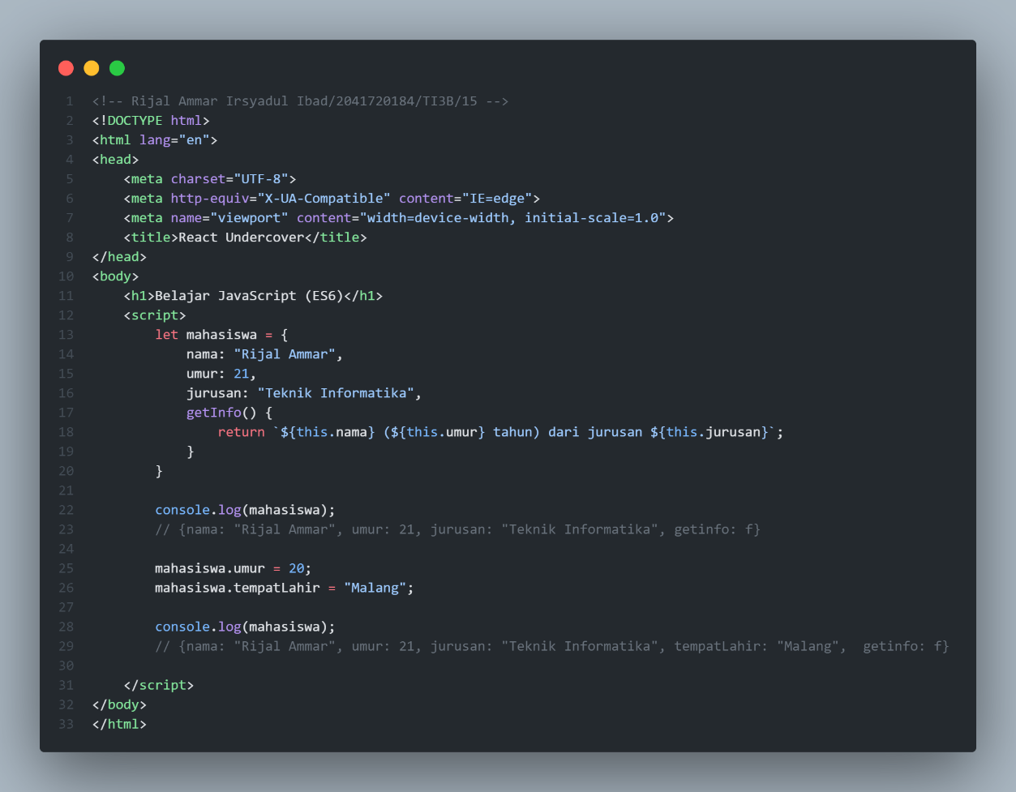

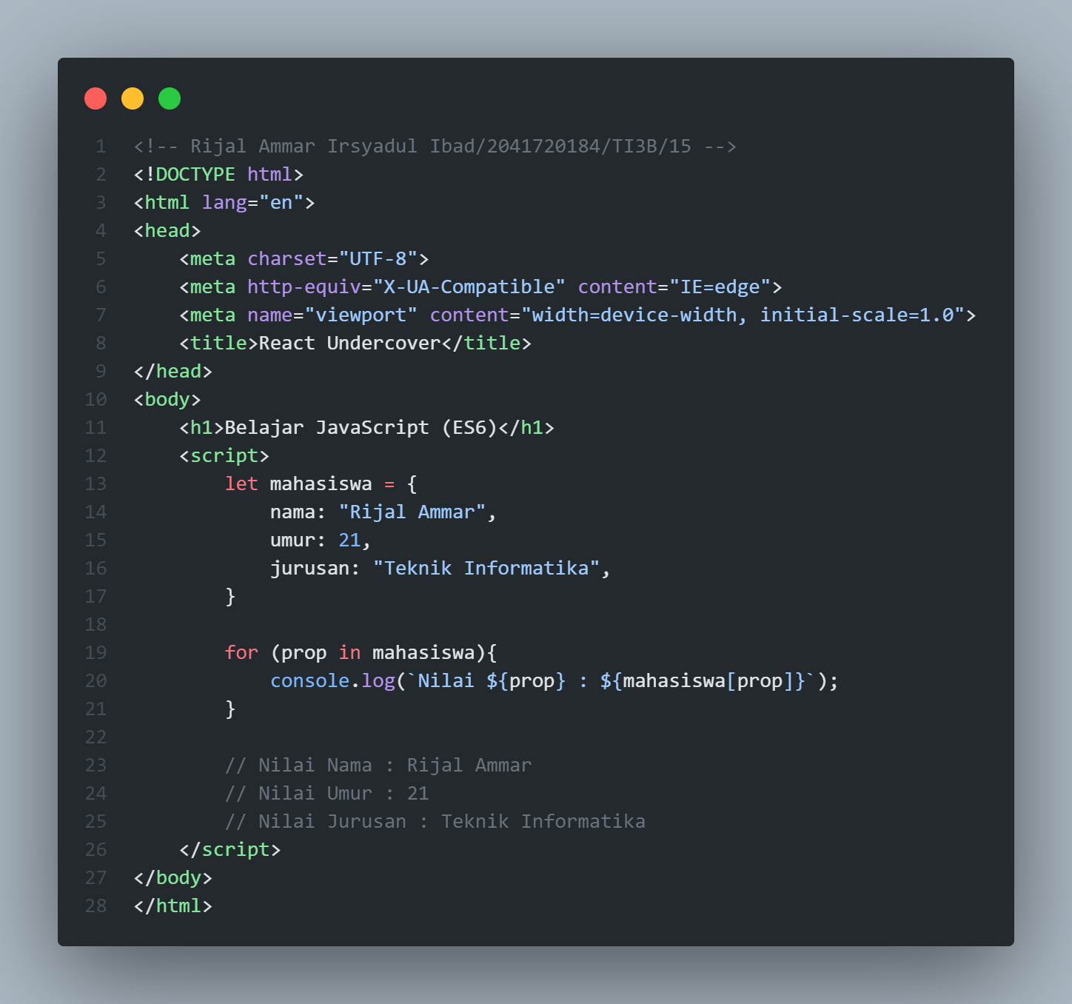

1. **Contoh Penggunaan Memproses Object pada JS**

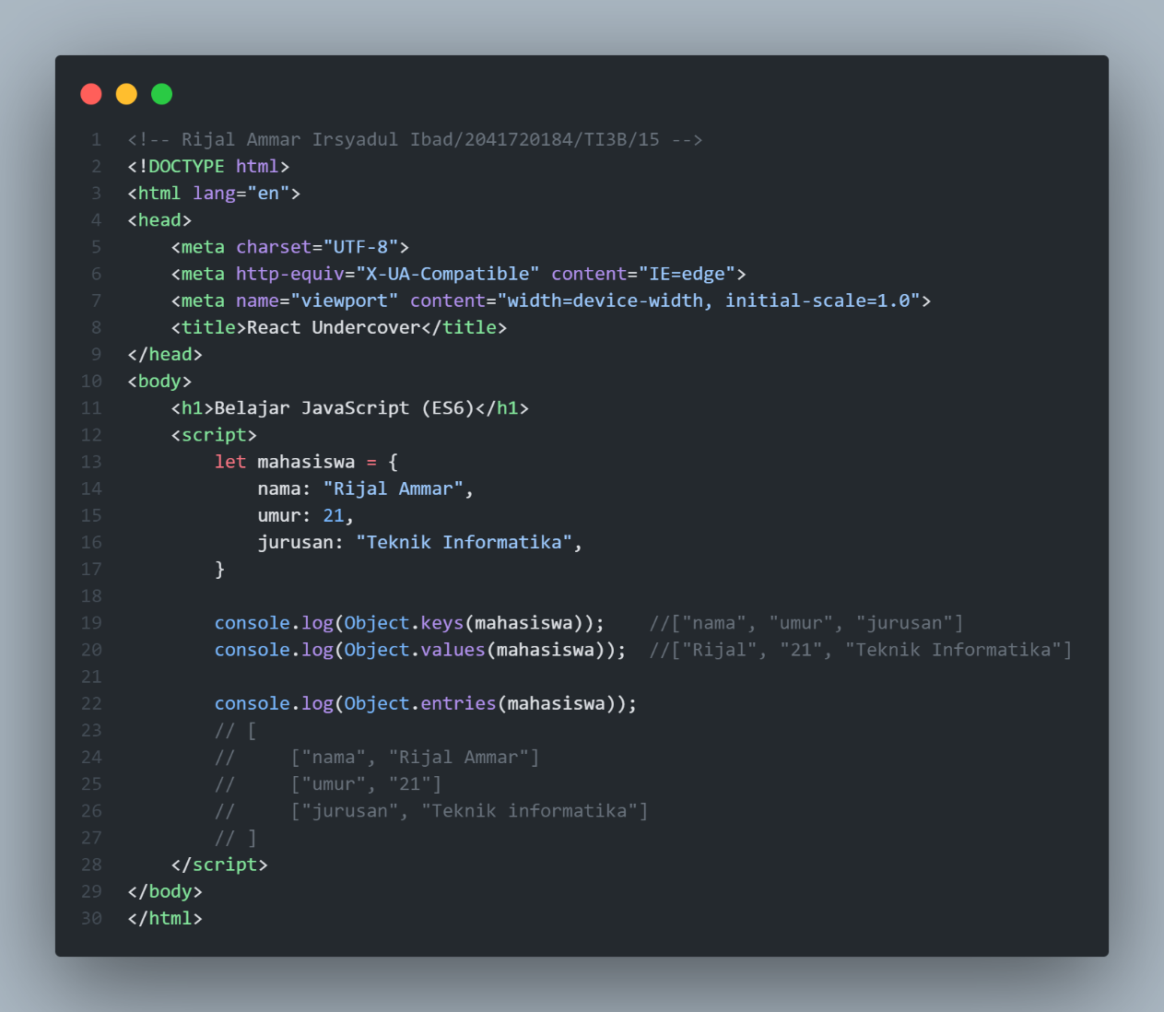

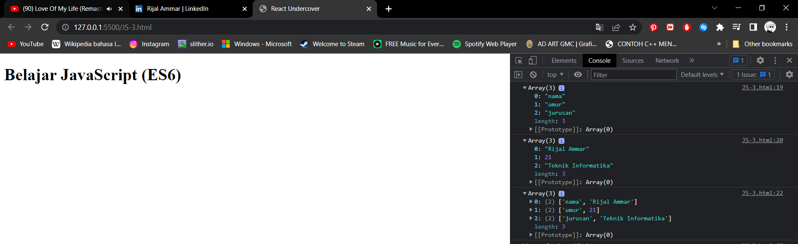

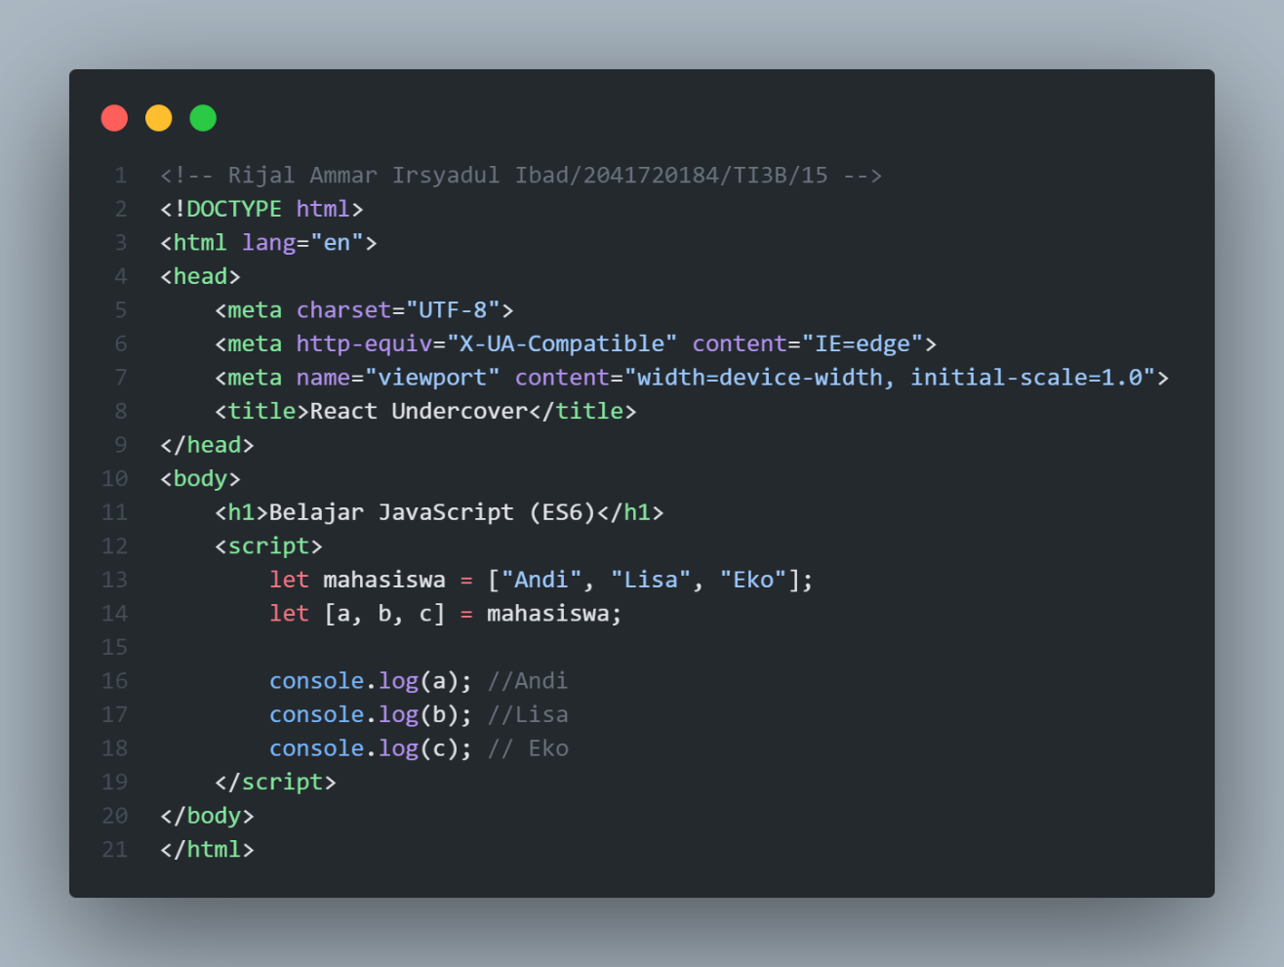

1. **Array dan Object Destructuring**

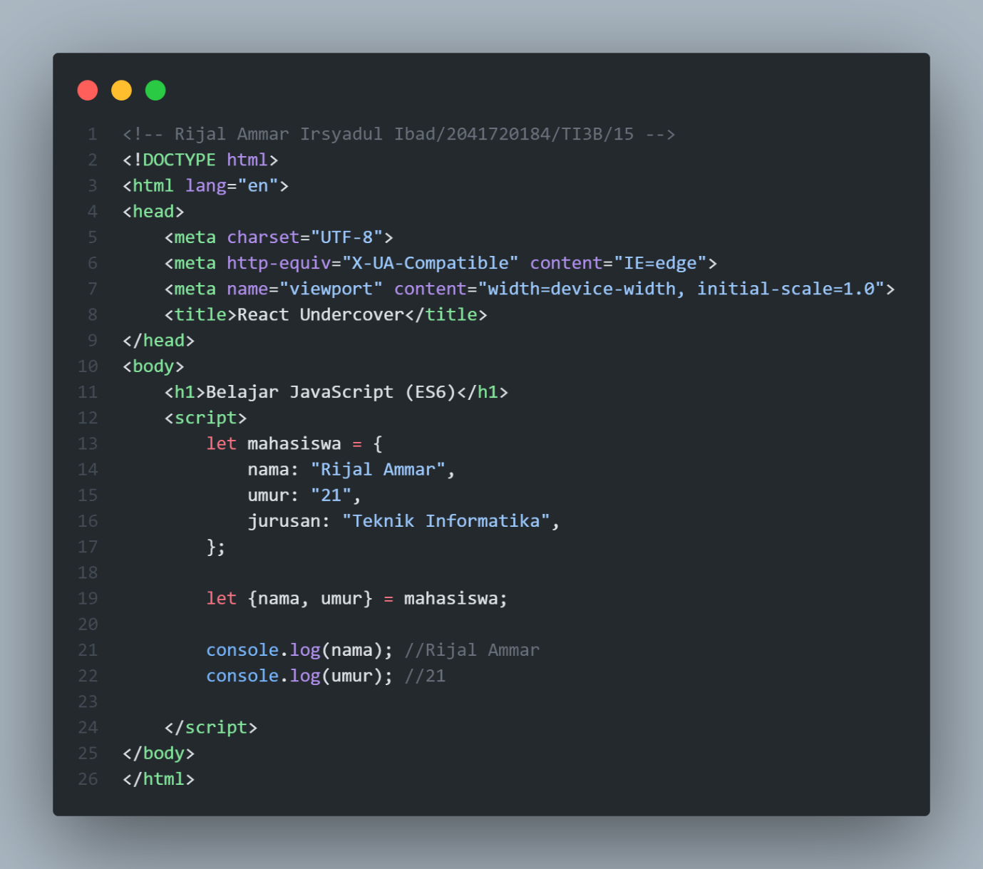

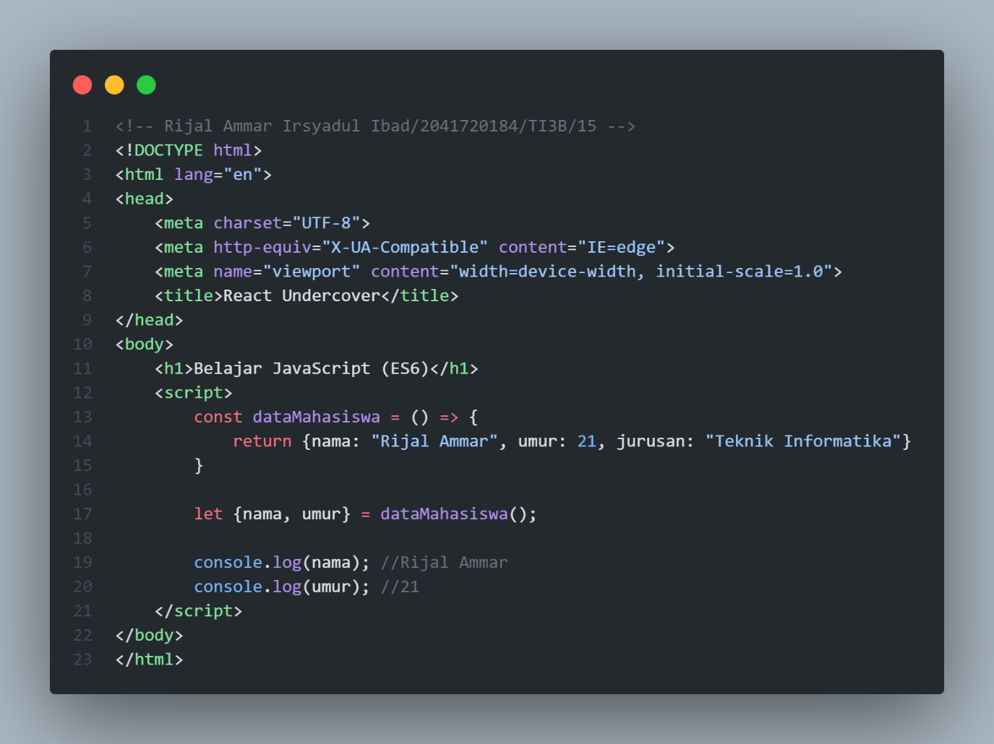

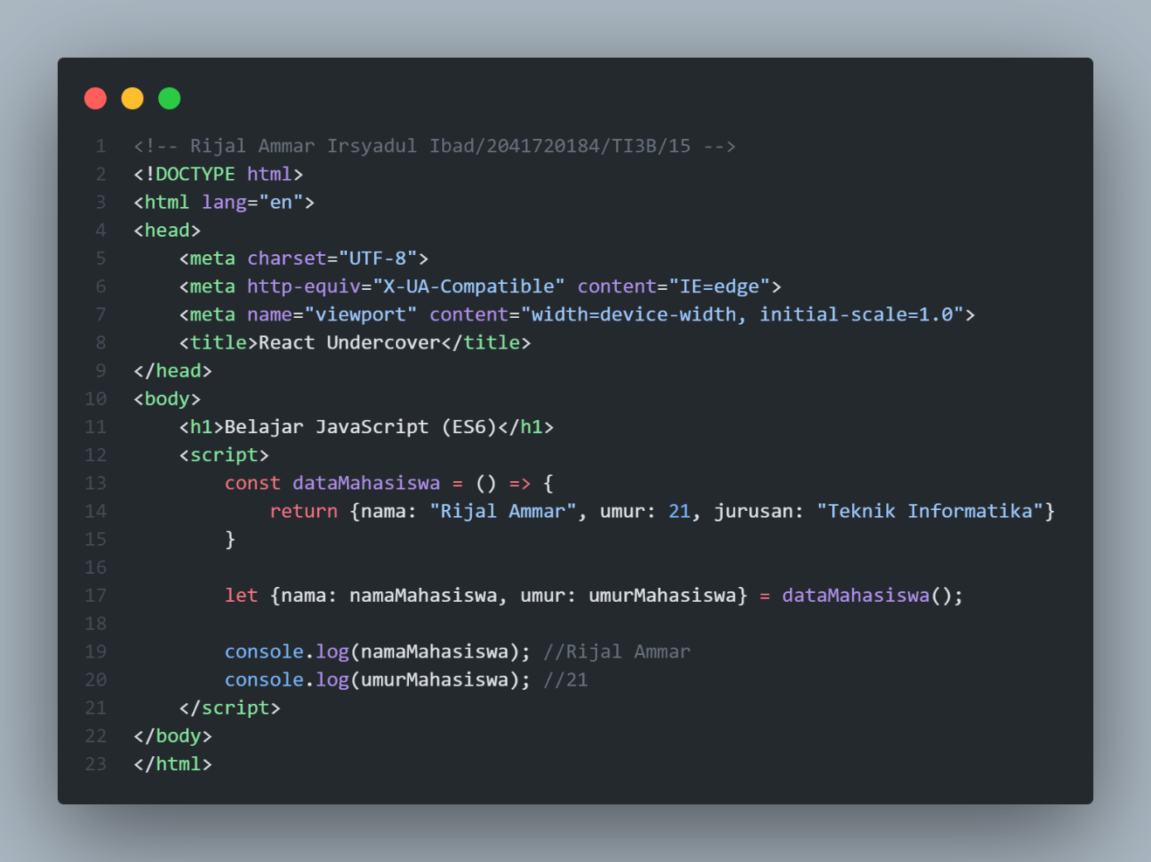

1. **Array Method: forEach() dan map()**

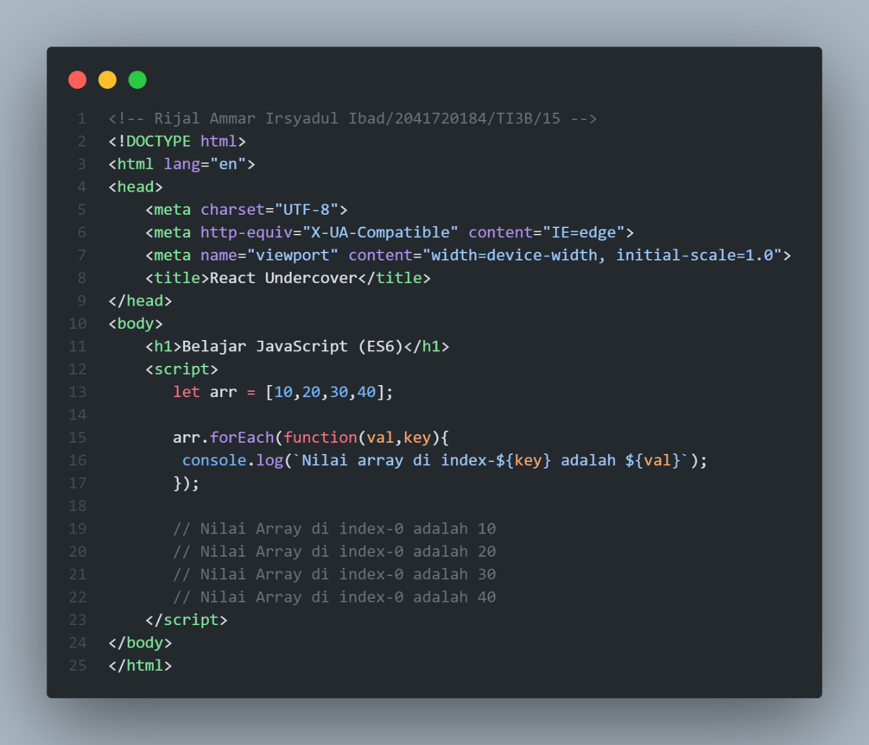

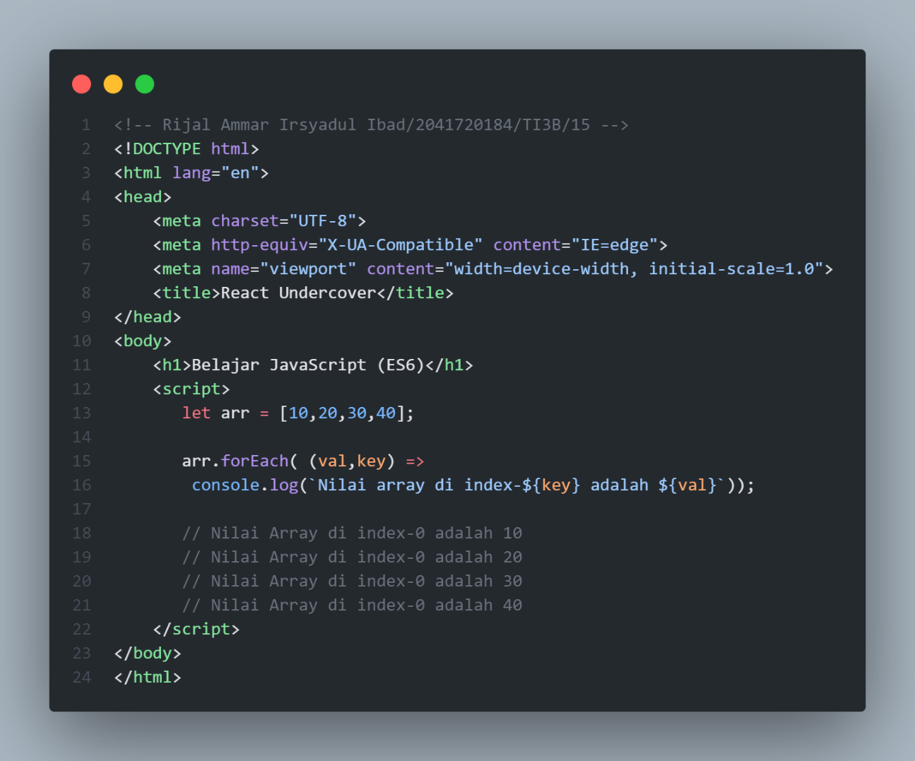

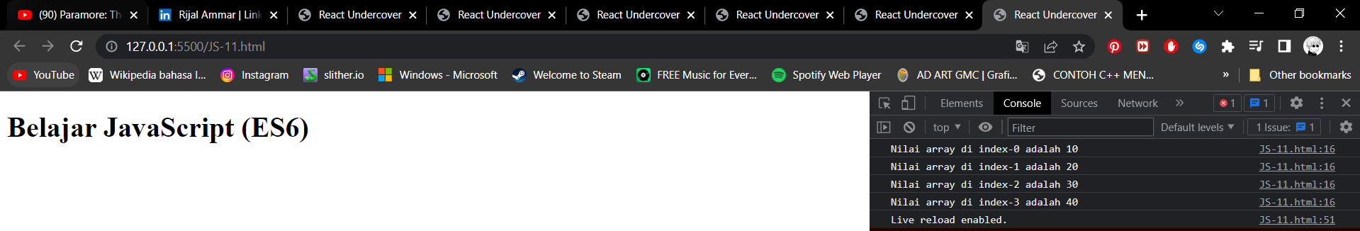

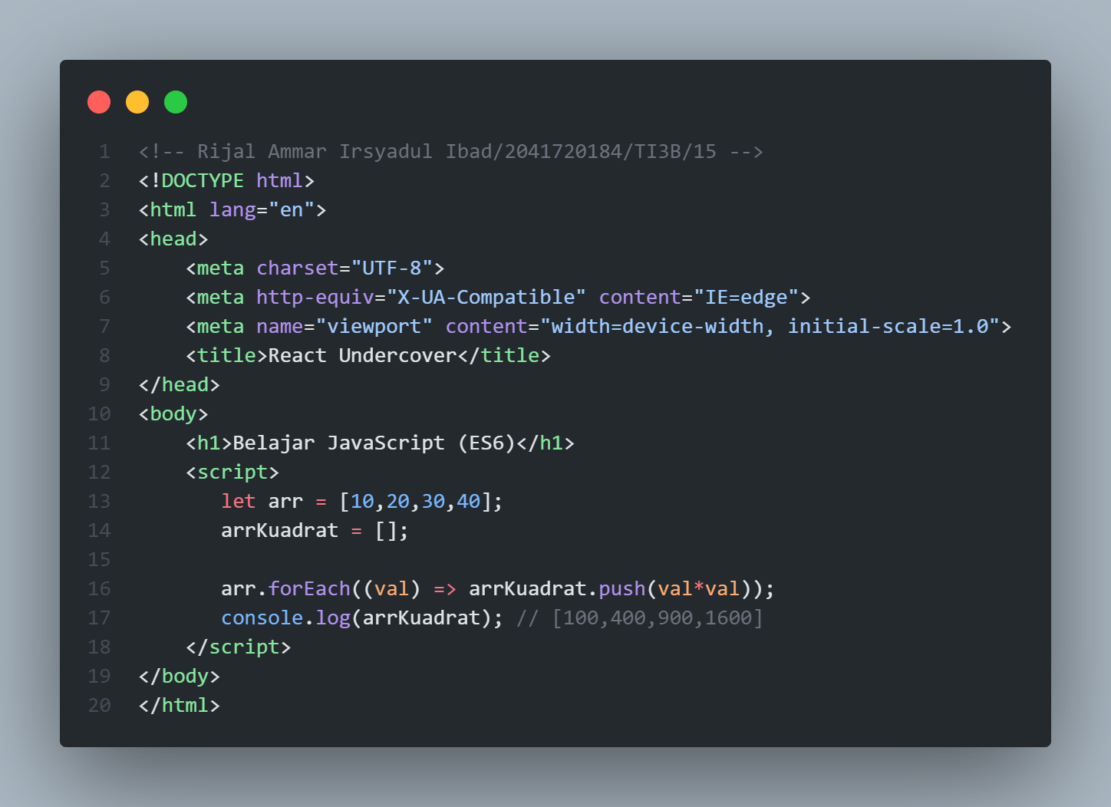

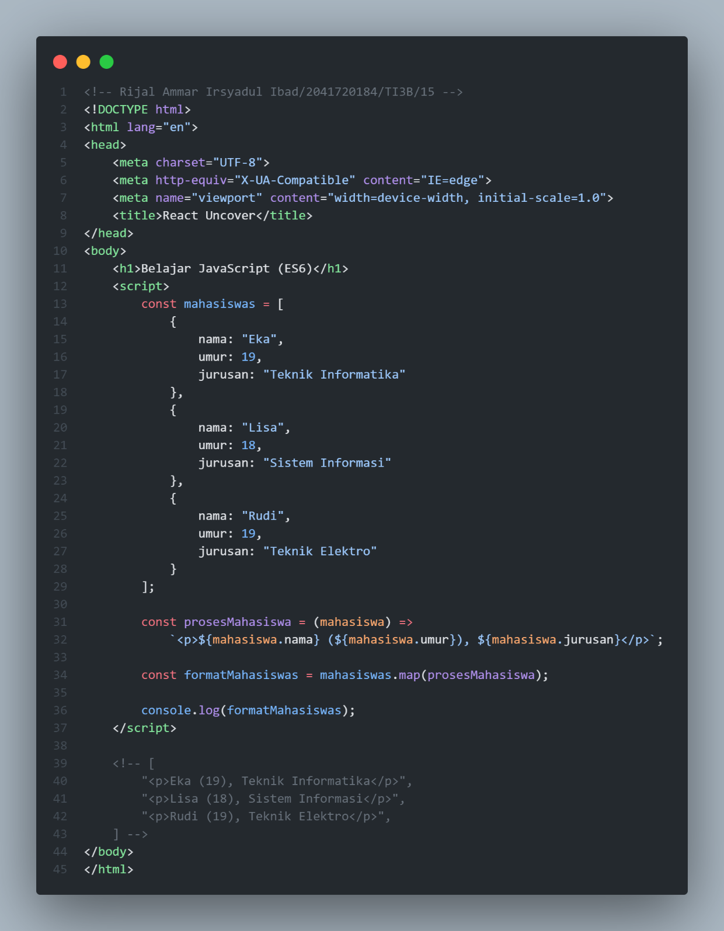

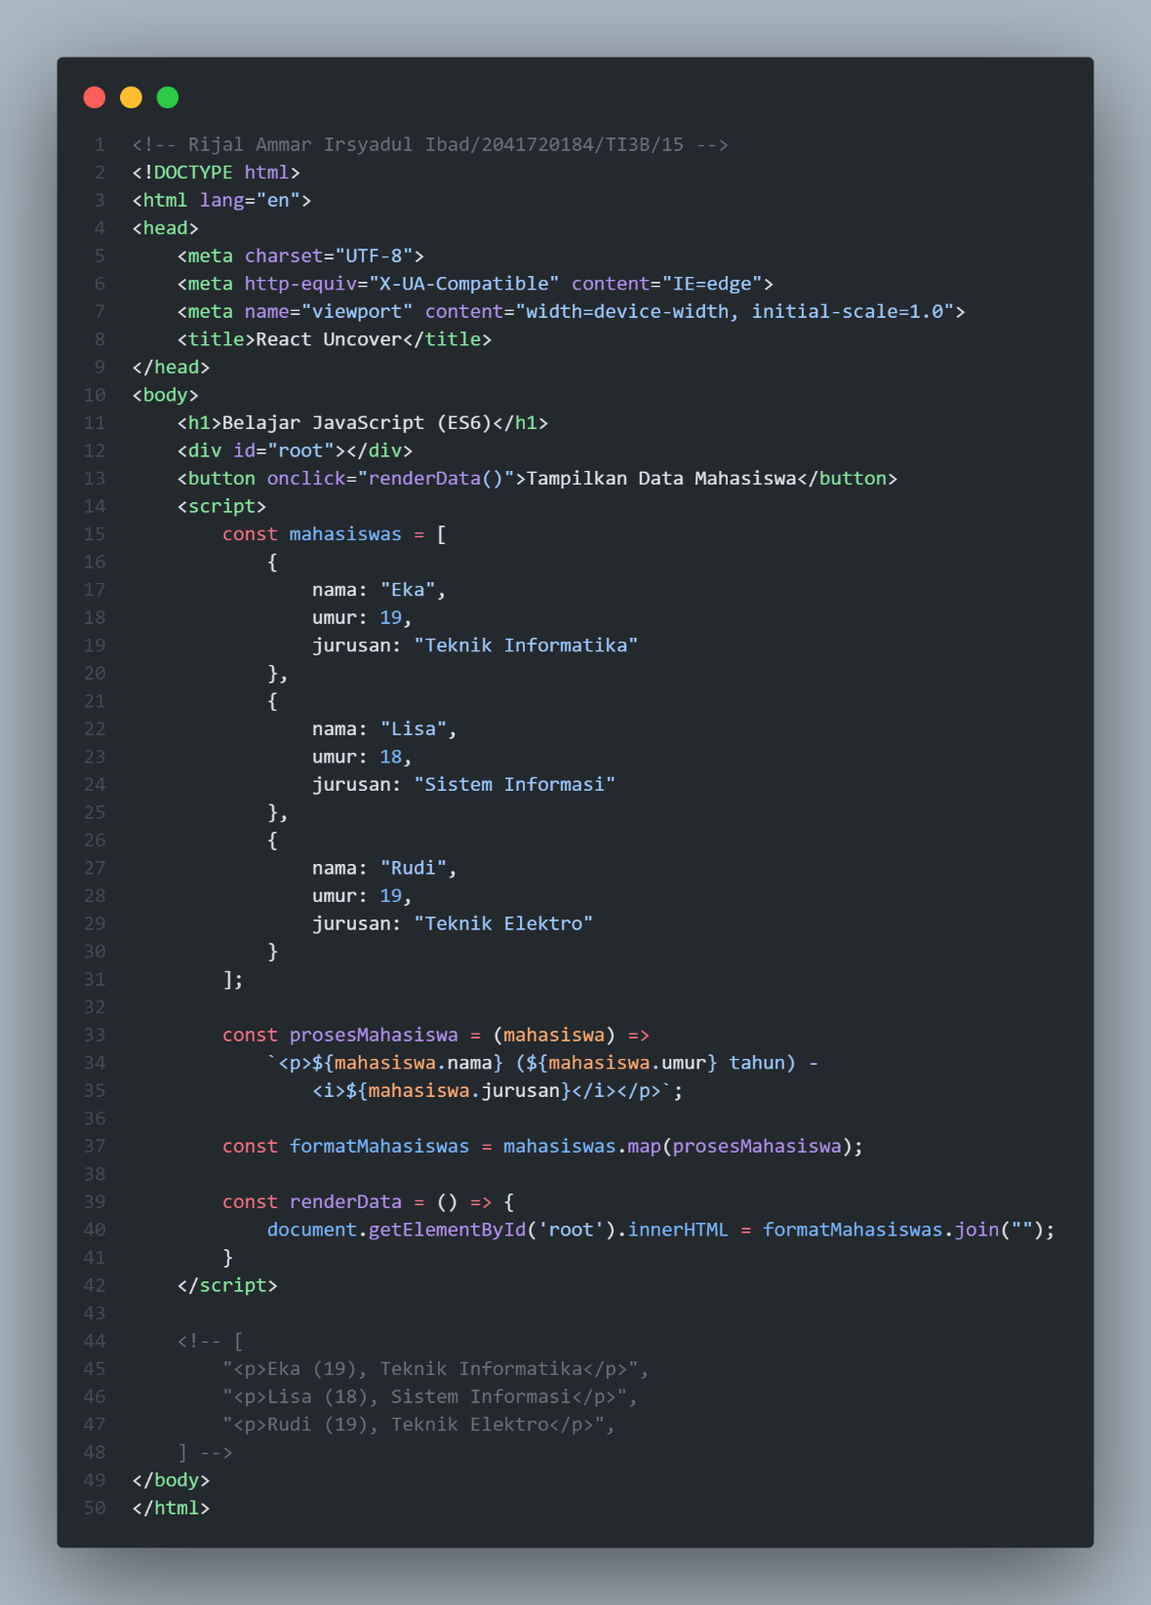

1. **Asynchronous JavaScript (Promise / Async - Await)**

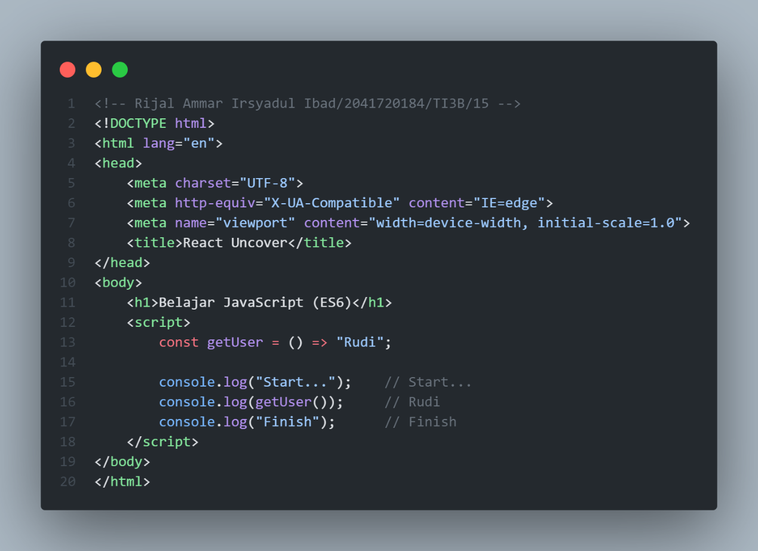

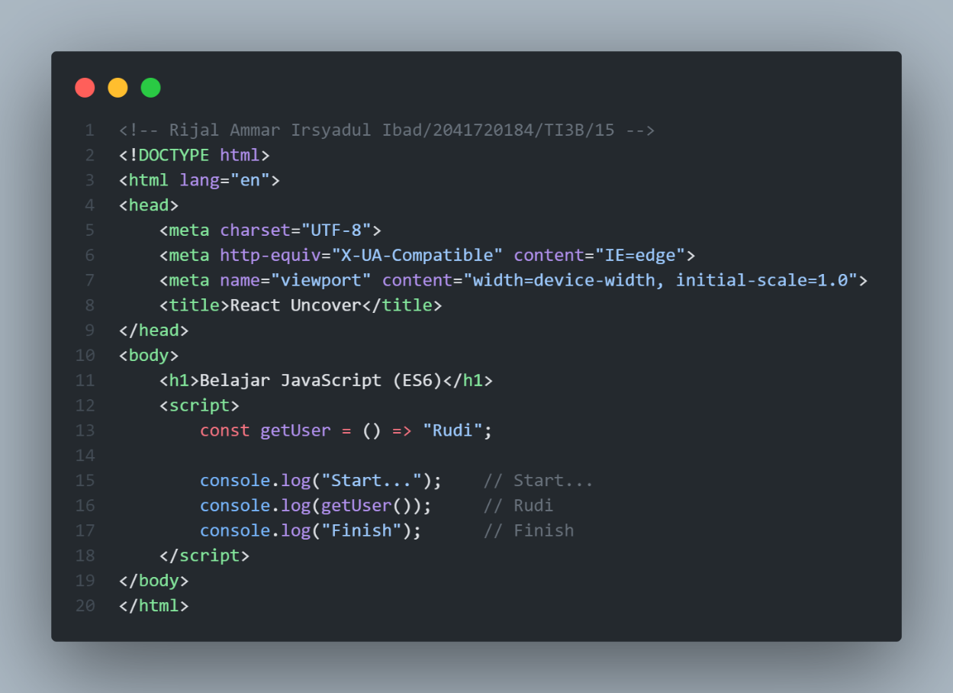

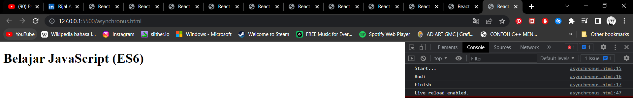

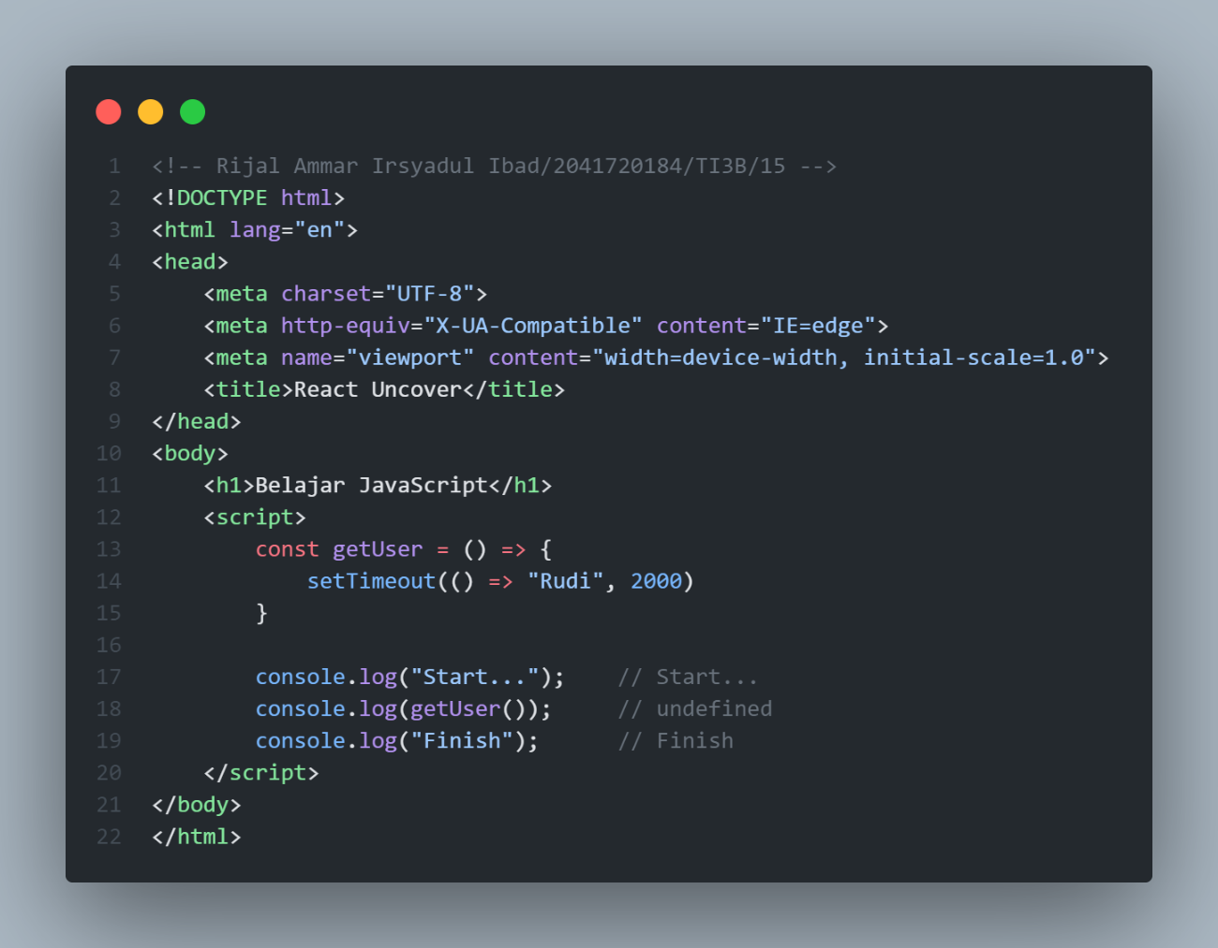

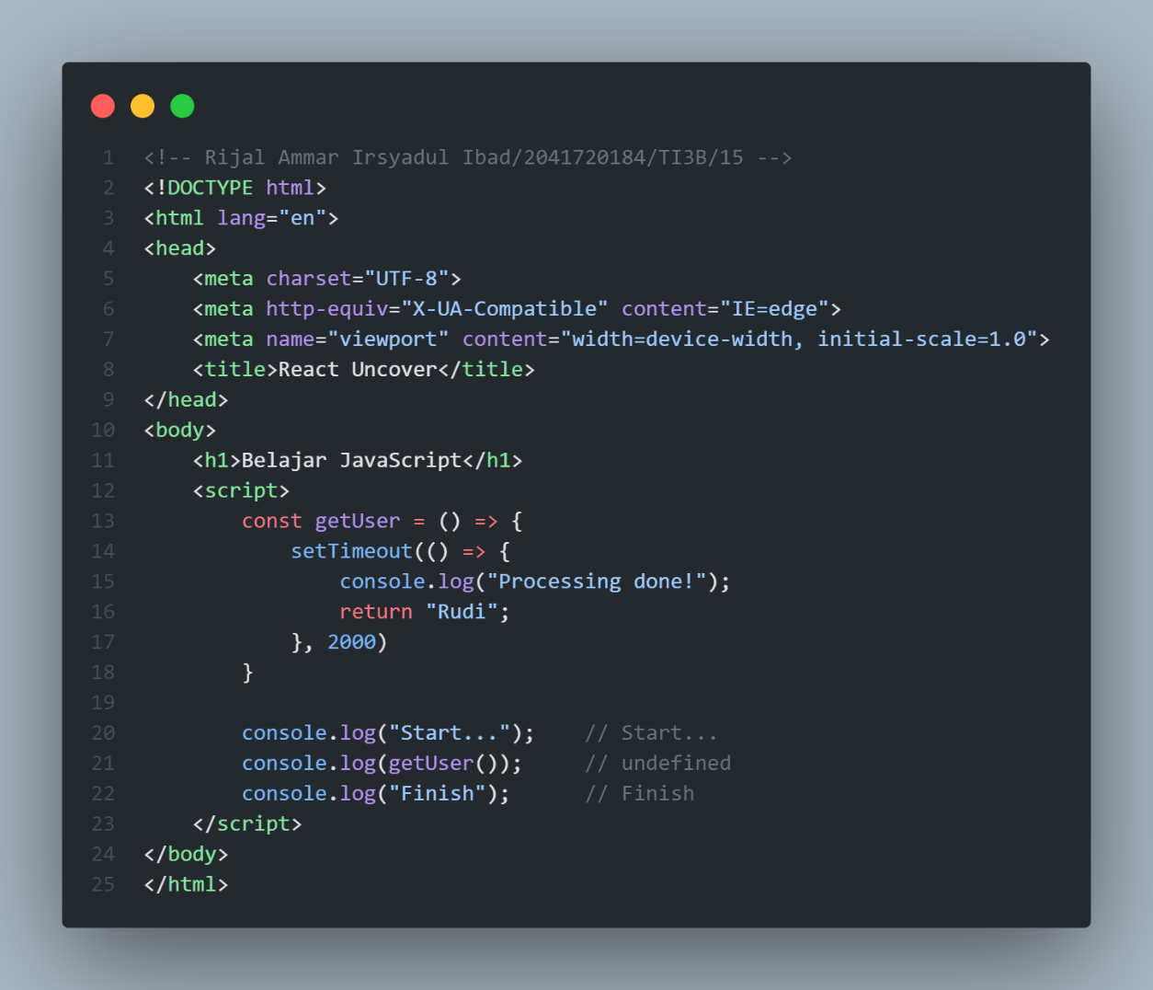

1. **Asynchronous JavaScript (Promise / Async - Await)**

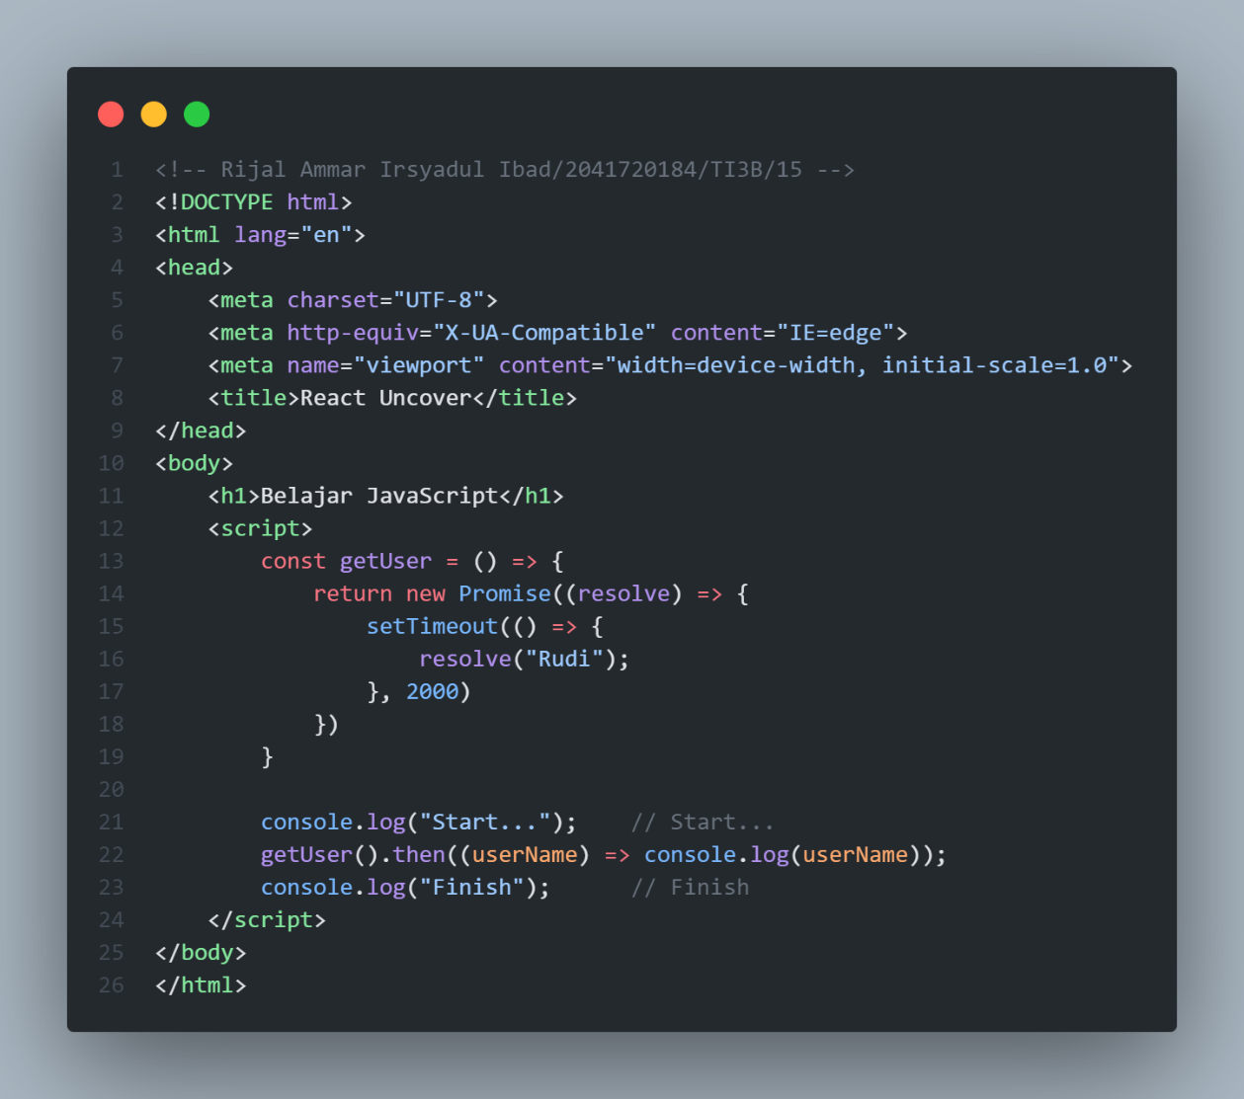

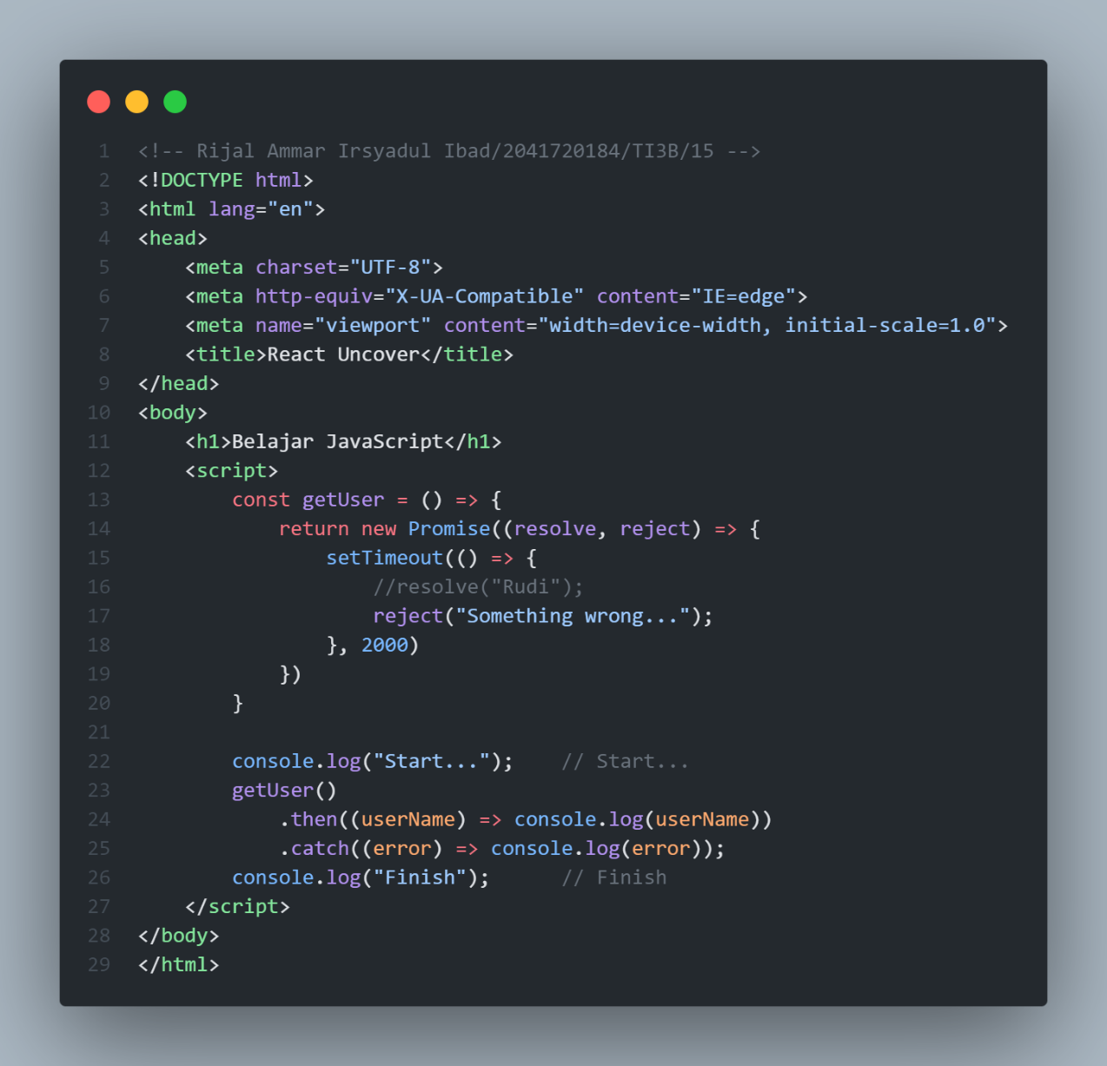

1. **Async – Await**



